Exercise 9

Objectives

1. List the features of ES6.

ES6 (ECMAScript 2015) introduced major improvements to JavaScript. It added let, const, arrow functions, default parameters, and template literals. Introduced classes, modules, and enhanced object literals. New data structures like Set and Map were added. It also brought destructuring, spread/rest operators, and Promises for async programming.

2. Explain JavaScript let.

let is used to declare block-scoped variables in JavaScript. Unlike var, variables declared with let are not hoisted to the top of their scope. let can be updated but not re-declared in the same scope. Useful in loops and conditional blocks for cleaner and predictable scoping. Prevents common bugs caused by variable leakage outside blocks.

3. Identify the differences between var and let

var is function-scoped, while let is block-scoped. var declarations are hoisted and initialized with undefined; let is not initialized. let helps avoid accidental re-declarations, while var allows it. let is more predictable in loops and asynchronous operations. Overall, let is safer and preferred over var in modern JavaScript.

4. Explain JavaScript const

const declares read-only block-scoped variables. The variable must be initialized at the time of declaration. It cannot be reassigned, but if it's an object or array, its contents can be modified. Useful for defining constants and values that shouldn't change. Helps make code more predictable and easier to debug.

5. Explain ES6 class fundamentals

ES6 introduces class syntax as syntactic sugar over prototype-based OOP. A class contains a constructor and methods, defined using the class keyword. You can create objects using the new keyword with the class name. Classes support encapsulation, inheritance, and clean code organization. Makes object-oriented JavaScript more readable and familiar to Java/C++ users.

6. Explain ES6 class inheritance

You can extend a class using the extends keyword to create child classes. The super() function is used inside the child constructor to call the parent constructor. Inherited methods and properties can be overridden or reused. Promotes code reuse and modular design patterns. Inheritance in ES6 follows a more classical model, unlike prototypes in older JS.

7. Define ES6 arrow functions

Arrow functions are a shorter syntax for writing functions using =>. They do not have their own this — they inherit this from the parent scope. Best used for callbacks, array operations, and simple one-liners. Cannot be used as constructors and don’t bind arguments. Improves code readability and reduces boilerplate in function expressions.

8. Identify set(), map()

Set is a collection of unique values — duplicates are not allowed. Map is a collection of key-value pairs with keys of any type. Both preserve insertion order, unlike plain objects. Set methods include .add(), .has(), .delete() and Map includes .set(), .get(). Useful for faster lookups, uniqueness checks, and structured data storage.

[**ListofPlayers.js**](http://listofplayers.js)

**import React from 'react';**

**import players from './PlayersData';**

**function ListofPlayers() {**

**const lowScorers = players.filter(player => player.score < 70);**

**return (**

**<div>**

**<h2>All Players</h2>**

**<ul>**

**{players.map((player, index) => (**

**<li key={index}>**

**{player.name} - {player.score}**

**</li>**

**))}**

**</ul>**

**<h3>Players with score less than 70</h3>**

**<ul>**

**{lowScorers.map((player, index) => (**

**<li key={index}>**

**{player.name} - {player.score}**

**</li>**

**))}**

**</ul>**

**</div>**

**);**

**}**

**export default ListofPlayers;**

[**IndianPlayers.js**](http://indianplayers.js)

**import React from 'react';**

**import players from './PlayersData';**

**function IndianPlayers() {**

**const allPlayers = players;**

**const oddPlayers = allPlayers.filter((_, index) => index % 2 !== 0);**

**const evenPlayers = allPlayers.filter((_, index) => index % 2 === 0);**

**const [odd1, odd2, odd3, ...restOdd] = oddPlayers;**

**const [even1, even2, even3, ...restEven] = evenPlayers;**

**const T20Players = allPlayers.slice(0, 5);**

**const RanjiPlayers = allPlayers.slice(5);**

**const mergedPlayers = [...T20Players, ...RanjiPlayers];**

**return (**

**<div>**

**<h2>Odd Players</h2>**

**<ul>**

**<li>{odd1.name}</li>**

**<li>{odd2.name}</li>**

**<li>{odd3.name}</li>**

**{restOdd.map((players, index) => (**

**<li key={index}>{players.name}</li>**

**))}**

**</ul>**

**<h2>Even Players</h2>**

**<ul>**

**<li>{even1.name}</li>**

**<li>{even2.name}</li>**

**<li>{even3.name}</li>**

**{restEven.map((players, index) => (**

**<li key={index}>{players.name}</li>**

**))}**

**</ul>**

**<h2>Merged T20 Players and Ranji Players</h2>**

**<ul>**

**{mergedPlayers.map((player, index) => (**

**<li key={index}>{player.name} - {player.score}</li>**

**))}**

**</ul>**

**</div>**

**);**

**}**

**export default IndianPlayers;**

[**PlayerData.js**](http://playerdata.js)

**const players = [**

**{ id: 1, name: "Virat Kohli", country: "India", score: 85, matches: 254 },**

**{ id: 2, name: "Steve Smith", country: "Australia", score: 92, matches: 128 },**

**{ id: 3, name: "Kane Williamson", country: "New Zealand", score: 88, matches: 151 },**

**{ id: 4, name: "Joe Root", country: "England", score: 89, matches: 104 },**

**{ id: 5, name: "Babar Azam", country: "Pakistan", score: 87, matches: 83 },**

**{ id: 6, name: "Rohit Sharma", country: "India", score: 78, matches: 243 },**

**{ id: 7, name: "David Warner", country: "Australia", score: 65, matches: 128 },**

**{ id: 8, name: "Quinton de Kock", country: "South Africa", score: 72, matches: 124 },**

**{ id: 9, name: "KL Rahul", country: "India", score: 68, matches: 42 },**

**{ id: 10, name: "Ben Stokes", country: "England", score: 74, matches: 104 },**

**{ id: 11, name: "MS Dhoni", country: "India", score: 91, matches: 350 },**

**{ id: 12, name: "AB de Villiers", country: "South Africa", score: 95, matches: 228 },**

**{ id: 13, name: "Hardik Pandya", country: "India", score: 62, matches: 66 },**

**{ id: 14, name: "Jasprit Bumrah", country: "India", score: 45, matches: 72 },**

**{ id: 15, name: "Pat Cummins", country: "Australia", score: 38, matches: 95 }**

**];**

**export default players;**

[**App.js**](http://app.js)

**import React from 'react';**

**import IndianPlayers from './IndianPlayers';**

**import ListofPlayers from './ListofPlayers';**

**function App()**

**{**

**const flag = true;**

**return(**

**<div>**

**<h1>Cricket App</h1>**

**{flag ? <ListofPlayers/> : <IndianPlayers/>}**

**</div>**

**);**

**}**

**export default App;**

**Output:**

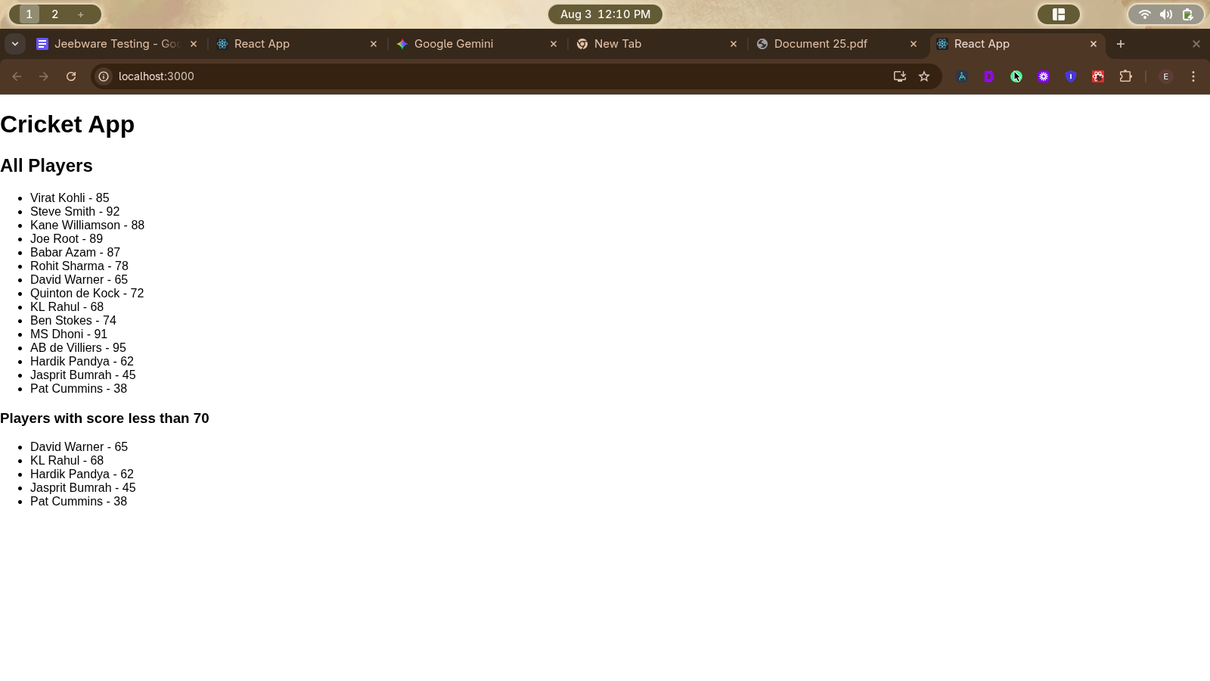

**When false:**

**import React from 'react';**

**import IndianPlayers from './IndianPlayers';**

**import ListofPlayers from './ListofPlayers';**

**function App()**

**{**

**const flag = false;**

**return(**

**<div>**

**<h1>Cricket App</h1>**

**{flag ? <ListofPlayers/> : <IndianPlayers/>}**

**</div>**

**);**

**}**